# **Thailand for Couples: Best Islands for a Romantic Getaway**

When it comes to a romantic holiday, Thailand for couples is always on top of our minds. And how could it not be with its pristine beaches, happy people, and multiple adventures for two?

If your love language is drinking mojito on the beach in between sessions of back massages and water splashes, we feel you. Whether you're on a honeymoon or simply want to enjoy a memorable escape with your partner, Thailand will be your safe haven.

Although we love a destination that gives options, when it comes to Thailand's 1,430 islands, it tends to get a little overwhelming. To give you a hand, we've rounded our top island recommendations for an unforgettable Thailand getaway. Our criteria? Romance at all costs!

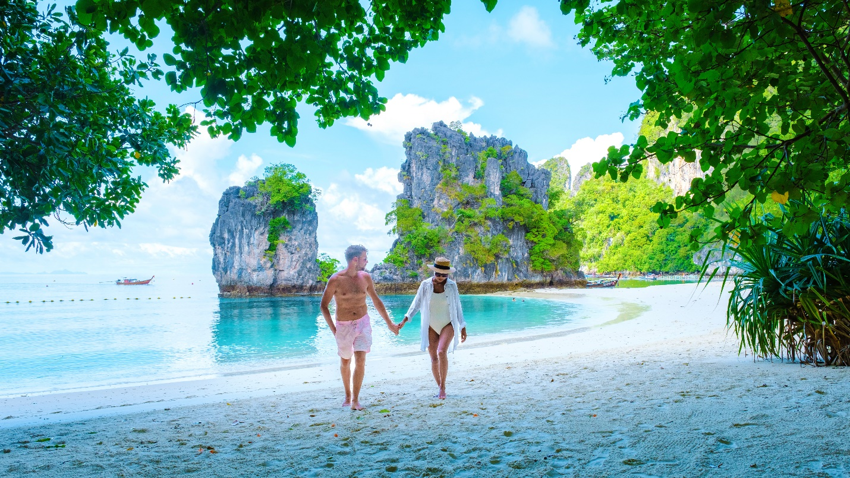

*Best place in Thailand for couples*

## 

## **Top Islands for a Couples' Trip to Thailand**

We can't deny that Bangkok is a gorgeous capital city and a must for your Thailand trip. But if you're a beach lover and an island kid at heart, you'll be better off the shore. Here are the best places in Thailand for couples:

### **1. Koh Lipe for Laid-back Holidays**

Koh Lipe is nothing short of idyllic if you're looking for an off-the-beaten-track destination. Lose all schedules and agendas here as you immerse in total relaxation in one of the lesser-known parts of Thailand.

Koh Lipe is more of a backpacker destination than a luxury resort, which is why it's charming. There are no cars on the island and very few roads, so you can stroll the streets in serenity without the noise and pollution. If it strikes your fancy, you can hop on a taxi boat ride to different island parts.

Your days here will be filled with swims alongside tropical creatures, sunbathing on powdery beaches, and savoring Thai cuisine. The waters will remind you of the[Maldives](https://haloholidays.co.uk/), and the vibrant coral reefs will transport you to another world.

What's romantic:

* Sunsets and sunrise views on Sunset Beach
* Snorkelling and scuba diving with your special someone
* Romantic hikes to Adang Viewpoint for a panoramic view of the island

### **2. Phi Phi Islands for Stunning Beaches**

Arguably one of the most popular islands and one of the best places in Thailand for couples. This cluster of six islands in the heart of the Andaman Sea combines limestone rock formations, dazzling waters, and luxury spas for total rejuvenation.

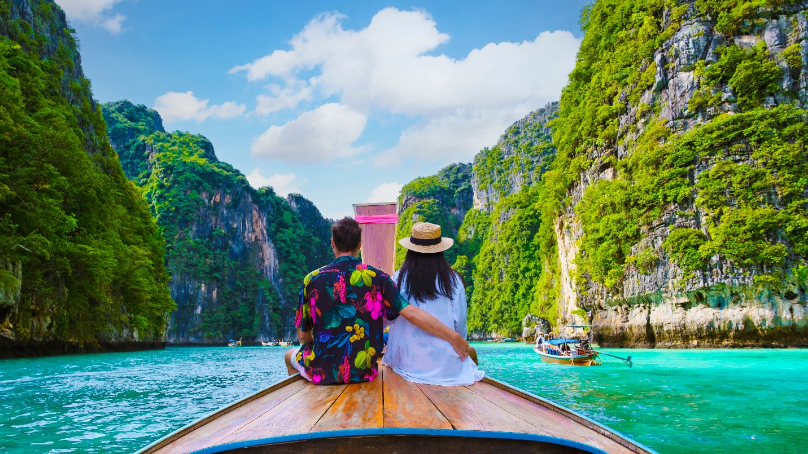

Picture sinking into a hammock in your partner's hug with a cocktail at hand amid the lush tropical vegetation. Stop it; you'll make us blush! Koh Pai Island (also known as Bamboo Island) is literally shaped like a heart for hopeless romantics. Need more proof you should visit?

Similar to other islands on our list, Phi Phi Islands offer incredible viewpoints for an overview of the iconic scenery. Meanwhile, Koh Phi Phi Lee was the island where the famous Leonardo DiCaprio's movie The Beach was shot, so it tends to get super crowded.

What's romantic:

* Viewpoints overviewing the iconic landscape
* Boat trips under golden skies
* Dining options and nightlife

### **3. Koh Tao for the Vivid Nightlife**

We're super excited about this next recommendation for your all-inclusive Thailand holidays! Koh Tao is the epitome of breathtaking views due to its mountainous terrain. Popular viewpoints such as Suwan, Grape, and Mango offer a true feast for the eyes and cameras.

During the daytime, you can immerse yourself in water sports like scuba diving for bargain prices or enjoy a boat trip around the island. At night, you'll find countless lantern-lit restaurants for dreamy dinners with your lover.

Thai cuisine is delectable - think smokey pork with garlic and chilli or a soothing bowl of tom yum soup with shrimp. Finger-licking!

What's romantic:

* Dimly-lit restaurants
* Vibrant nightlife
* Sandy beaches and water sports facilities

### **4. Koh Samui for Luxurious All-Inclusive Thailand Holidays**

If you want to sparkle up your romance in a more convenient setting, Koh Samui is the largest and most popular island on the East Coast. Although a bit more commercialized than other Thailand destinations, it balances tranquility and excitement perfectly.

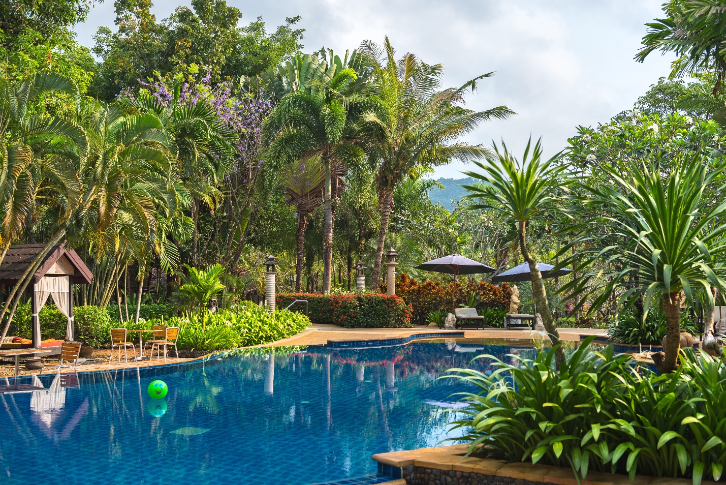

Here, you'll find luxurious resorts, massage huts, and beach bungalows at your fingertips. Craving traditional Thai cuisine? You got it! Looking to unwind in the day while partying at night? You're at the right place!

Although Koh Samui gathers partygoers and buzzy crowds among other audiences, it's still possible to spot heavenly quiet coves. So even if you don't want to have a rave-party at night but slow dance with your special someone under the moonlight, it's totally possible.

What's romantic:

* Late-night beats and fruity cocktails
* Luxury resorts and wellness spas
* Beachfront restaurants and vivid nightlife

*Couples trip to Thailand*

### **5. Mu Koh Lanta National Park for the Delectable Cuisine**

Yet another group of islands established as a national park in the 90s. For those looking to blend in with the locals, Mu Koh Lanta is home to friendly fishing villages where warm people will greet you with the biggest of smiles.

This is the epitome of Thailand for couples and the perfect opportunity to get an authentic taste of how people live there. Especially if you're into fishing, you'll be amazed by the colourful long-tail fish boats, the tropical catches, and the delicious seafood dinners.

You can even take cooking classes to add a playful aura to your romantic trip. If you fancy sprinkling some activities into your stay, you can kayak through the stunning mangrove forest or do some island hopping.

What's romantic:

* Picturesque fishing villages
* Interacting with the warm locals
* Enjoying fresh, mouth-watering seafood

## **Plan Your Next All-inclusive Thailand Trip!**

Whether a romantic escape means travelling to a peaceful destination with a clear calendar or packing your trip with exciting activities, Thailand offers it all. Hopefully, our list of the best places to visit in Thailand for couples will give you a clearer picture of what to expect and where to go.

Planning your all-inclusive Thailand holidays? At[Halo Holidays](https://haloholidays.co.uk/), we provide a hassle-free experience tailoring your trip to your needs. Whether you're travelling for a brief trip or an extended vacation, our impeccable team of experts will customize the experience for you.

[Get in touch today](https://haloholidays.co.uk/) and enjoy complete peace of mind.